Executive Summary
Entertrainment Web Site

Abstract
Whether it is movies, concerts, sporting events, or listening to motivational speakers, we all love to be entertained. For the most part, training is not entertaining, but it could and should be. When training is dull, the motivation to learn is decreased and that affects how much and how long information is retained.

As instructional designers, teachers, or presenters, we can infuse our presentations with interesting and fun activities, which will allow our audiences to experience training, rather than endure it.

Studies reveal that participants who were taught with such entertainment tools as humor, analogies, or stories achieved higher scores than those who had attended conventional lectures. Student negativism or hostility regarding difficult materials is also reduced. Instructors who are comfortable adding humor to their daily routine find that students are more open and communicative.

LivelyLearning.com is a one-stop source for information on entertrainment. This is the place where instructional designers (IDs), teachers, and presenters will come to learn, explore, and share ideas about infusing training with some lighthearted, entertainment elements. The goal is to enhance learner interest and thus improve the long-term retention of information.


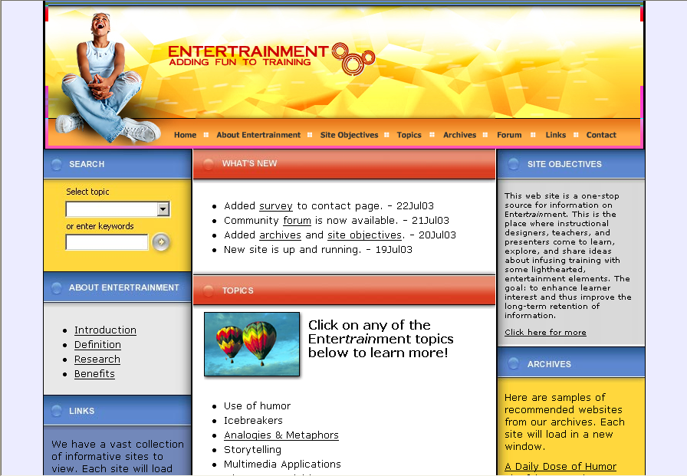
Problem:
Insufficient or dispersed information relating to entertaining educational activities—activities that will increase learners’ retention of information
Solution:
The LivelyLearning.com web site is a one-stop resource where IDs, teachers, and presenters come to learn, explore, & share ideas about how to enhance learner interest.
LivelyLearning
Web Site

At this time, there is no evidence of how much the site will be accessed or that the information will useful to the target audience. However, I do have a vision and I intend to do whatever is necessary to reach my goals. With this web site, I see:

- An attractive home page that provides a clear definition of entertrainment and why it is important to education.

- Tabbed sections for all the topics that fall under the entertrainment umbrella. Links will provide easy access to all internal pages and external web sites.

- Message boards and threaded discussions.

- “How-to,” interactive tutorials on a variety of entertrainment topics and techniques.

- An embedded survey form that will allow users to make comments and suggestions for site improvement.

Reflection
I have been an educator for more than 25 years. The idea of making training and education more interesting, more fun, and more engaging has always intrigued me. I am a firm believer in the quote:

Entertain me while you educate me. Make me laugh. Make me cry.
I want to escape from the narrow confines of my life, while deriving moral satisfaction from the hope that I am learning at the same time.
--Anonymous

Training and education should be more entertaining. It is my desire to help others find tools and techniques that will enhance their learners’ knowledge.

This project took a great deal of time and effort, but it has been both informative and rewarding. I learned a lot from my instructor, my cohorts, and from my son, Michael. It was a stretch for me to apply so many advanced principles into this site and I never would have been able to do it with their combined assistance. With regard to the infusion of information, at times I felt like I was “drinking out of a fire hose.”

LivelyLearning.com is in the infancy stage. I have all the foundational elements in place, but I need to do more research and expand on each of the topical areas.
Responsibilities Met
Responsibility #1 – Continued improvement of professional practice that requires critical inquiry, professional development, and reflective practice
The development of this web site involved advanced development practices and procedures, professional development and reflective practice, all of which are just the beginning of a much larger pursuit. The remaining work will continue after I graduate from the ILT program.

The goal of this web site is to provide a definitive, one-stop source for information about entertrainment. Hopefully, this will be the web site that instructional designers and presenters come to for definitions, benefits, ideas, and examples that relate to this often neglected form of education. The ultimate goal is to make education more fun while improving learner understanding and retention.

Responsibility #3 – Uses a variety of media to deliver instruction to students and to engage students in learning
This site provides an indirect benefit to students. By providing instructional developers and instructors with a tool to make education more interesting, the students win two ways: they will become more engaged in the learning process and the information they receive will be move from short to long term memory more quickly. The web site is a catalyst for making this happen, because it consolidates information, makes it easy to access, and provides an electronic forum for like-minded professionals.

